Day 1
- What is your favorite subject?
- What is your favorite and least favorite thing about Math?
- What do you hope to learn this year in Math?
- What is one short term goal for this year?
- What is one long term goal for this year?
Day 2
- In what order do we perform operations? What anagram do we use to remember the order?
- For 7 + 5 – 3 x 2, which operation would we perform first?
- If we have two multiplication signs, which one would we perform first?
- Solve: (10 ÷ 2 – 3) x 4
- Solve: 4² – 3 x (2 + 1)

Day 3
- What must be the same for two terms to be alike?
- Combine ALL like terms: 3x² – 2x + 5 + x² + 4x – 3
- Which operation do we use for Distributive Property?
- Distribute: 3(x + 1)
- Distribute: 4(x + 4) – 3x
Day 4
- Write a +sign if the number is positive and a –sign if the number is negative:
6 _____________ -4 ______________
- Using Heaps and Mounds, model 6 and -4:
6 _____________ -4 ______________
- On the number line, mark 6 and -4:
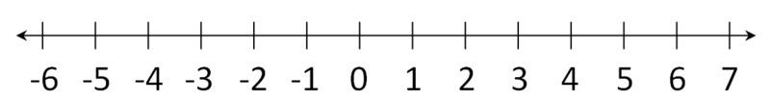
- What is absolute value?
- What is |-6|?

