Monday
- Solve: 3(4 – 2) + 2(6 ÷ 2)
- Combine all like terms: 4 + 2x + 7 – x – 3
- Distribute AND THEN combine all like terms: 3(x – 7) + 2x – 2(x + 1)
- Model -5 and 3 using Heaps and Mounds:
-5 ______________ 3 _______________
- Solve: |-4| – 1
Tuesday
- Using the symbols below and zero pairs, what is -2 + 3?
+ + +
- -
- Using symbols and zero pairs, what is 5 + (-7)?
- Using heaps and holes, what is 6 + (-2)?
___________________
- Using heaps and holes, what is -7 + 3?
___________________
- Using a number line, what is 4 + (-6)?
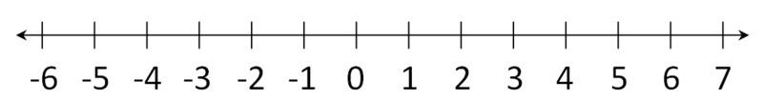
Wednesday
- Using the symbols below, what is 5 – 2?
+ + + + +
- Using symbols and zero pairs, what is 3 – 5?
- Using heaps and holes, what is 2 – 6?
- Using heaps and holes, what is -7 – 4?
- Using a number line, what is 5 – 8?

Thursday
- Using any method, what is 2 – 6?
- Using any method, what is -3 + 5?
- Using any method, what is -1 + 8?
- Using any method, what is 4 – 9?
- Using any method, what is 3 – (-4)?

